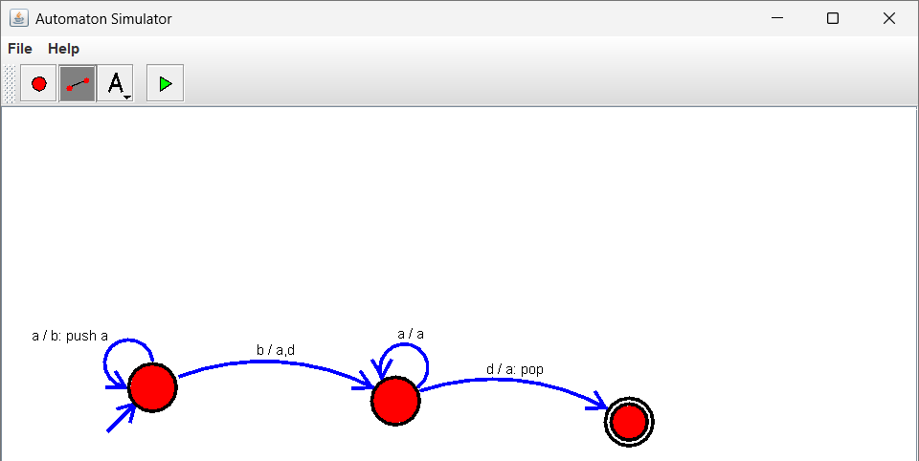
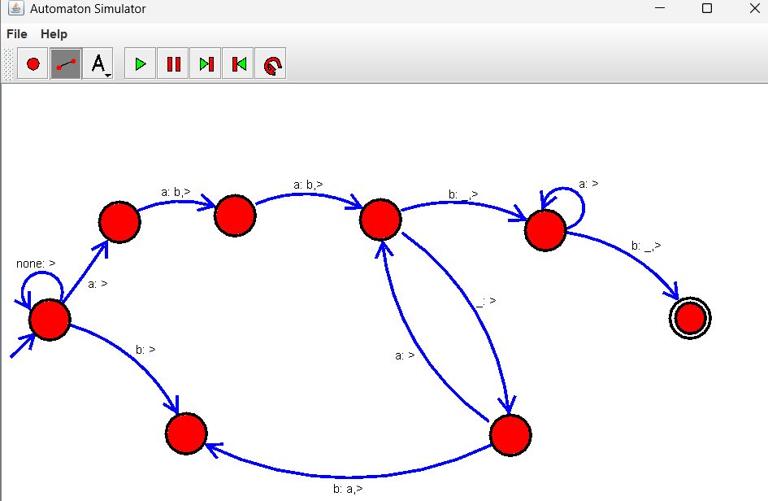
- Design PDA using simulator to accept the input string anbn
- Design TM using simulator to perform string comparison where w={aba aba}

- Design DFA using simulator to accept the string having ‘abc’ as substring over the set {a,b,c}

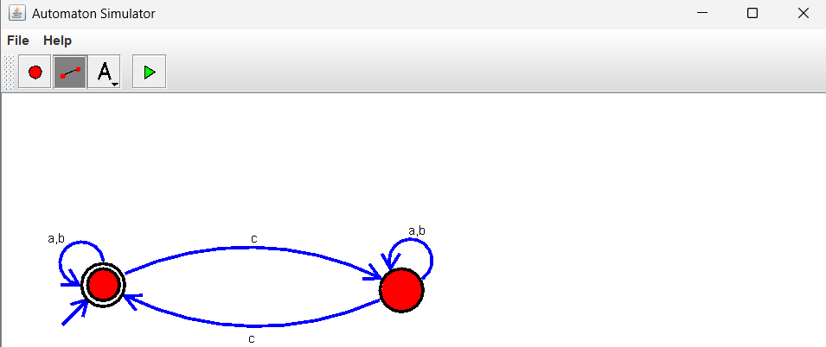
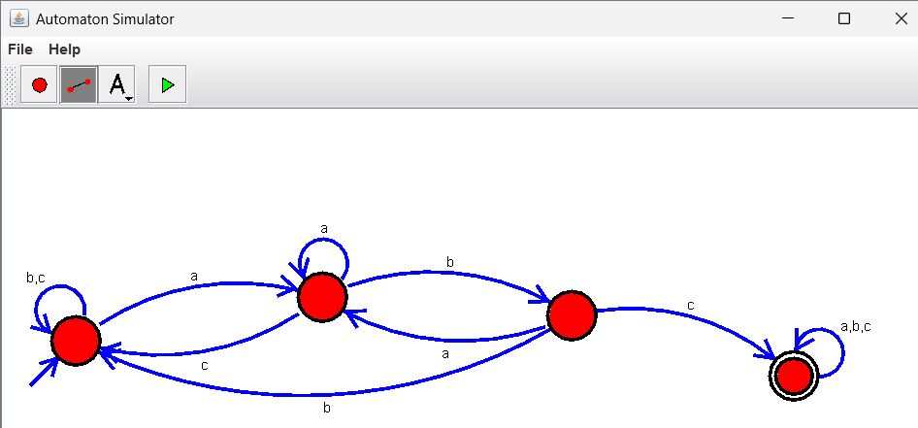
- Design DFA using simulator to accept even number of c’s over the set {a,b,c}

- Design DFA using simulator to accept strings in which a’s always appear tripled over input {a,b}

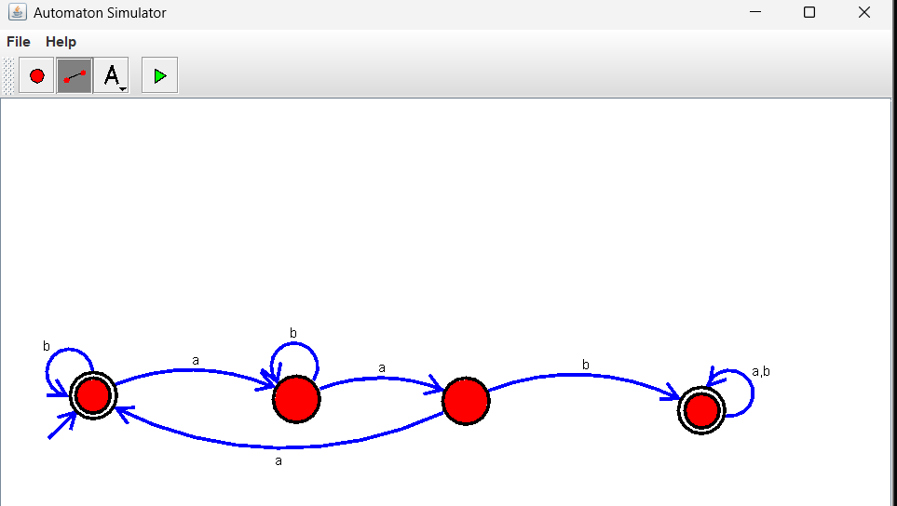

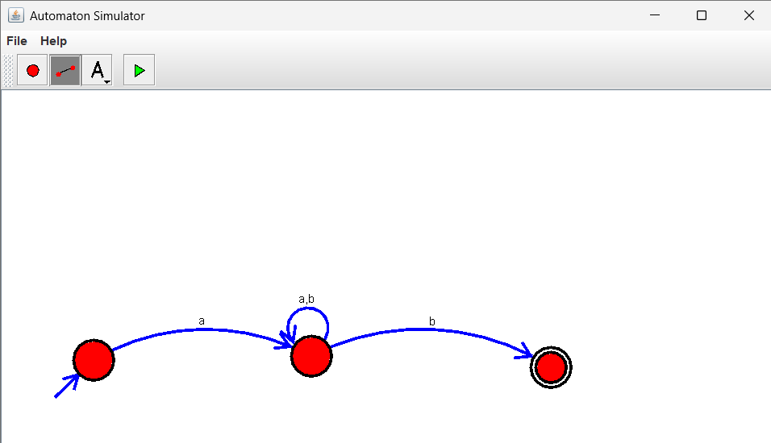
- Design NFA using simulator to accept the string the start with a and end with b over set {a,b} and check W= abaab is accepted or not.

- Design NFA using simulator to accept the string that start and end with different symbols over the input {a,b}.

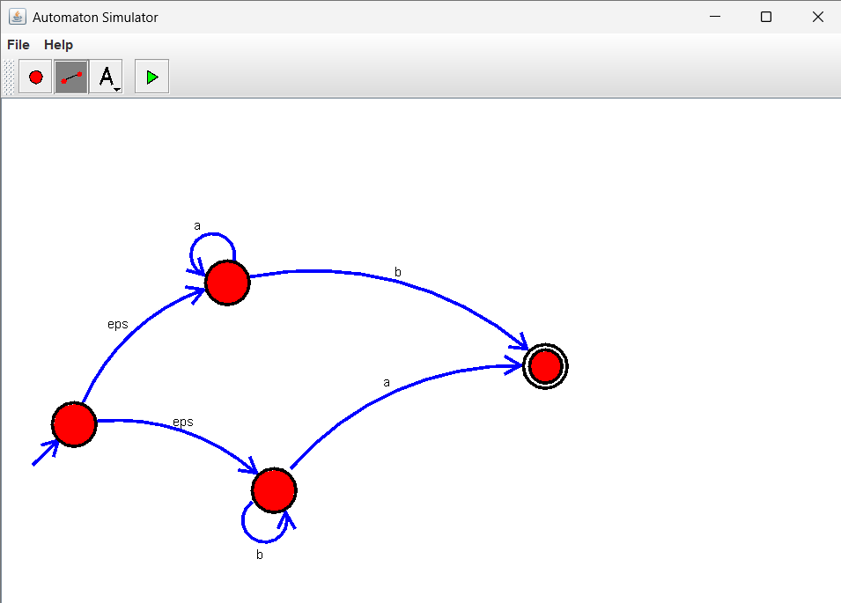

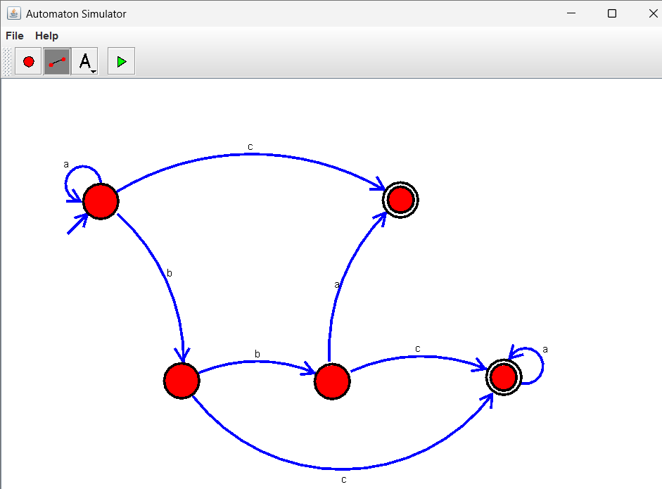
- Design NFA using simulator to accept the input string “bbc” ,”c”,and ”bcaaa”.

- Design DFA using simulator to accept the string the end with abc over set
{a,b,c) W= abbaababc

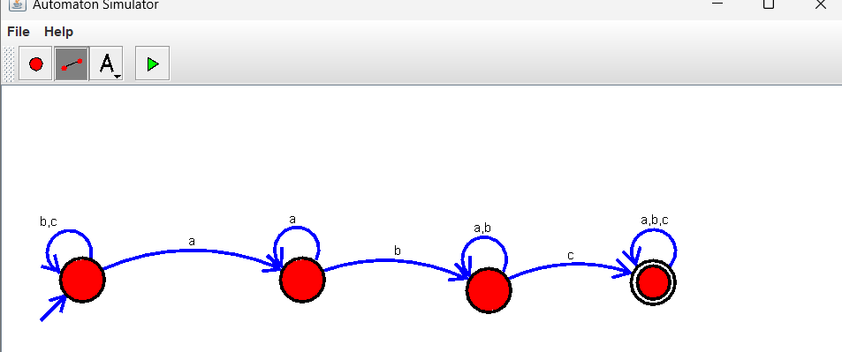

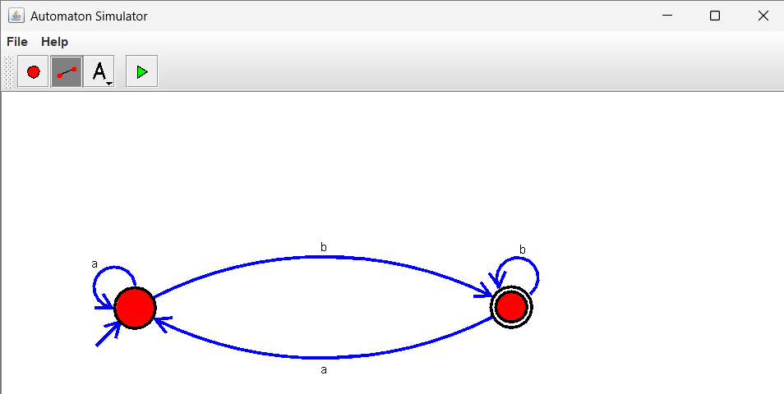
40. Design NFA to accept any number of b’s where input={a,b}.

